Secondary consumers

**Tundra energy Pyramid**

Snowy Owl & Artic Fox

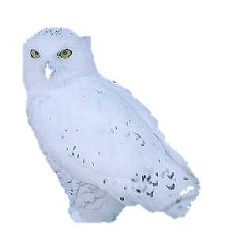6 kc

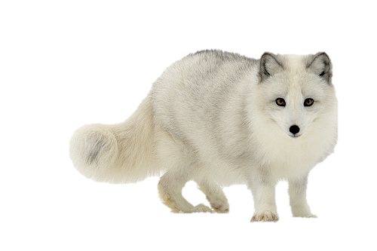

Primary consumers

Musk Oxen &

Lemmings

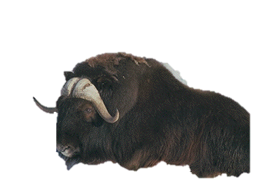60 kc

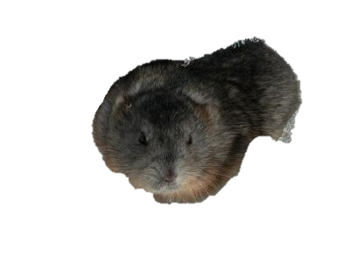

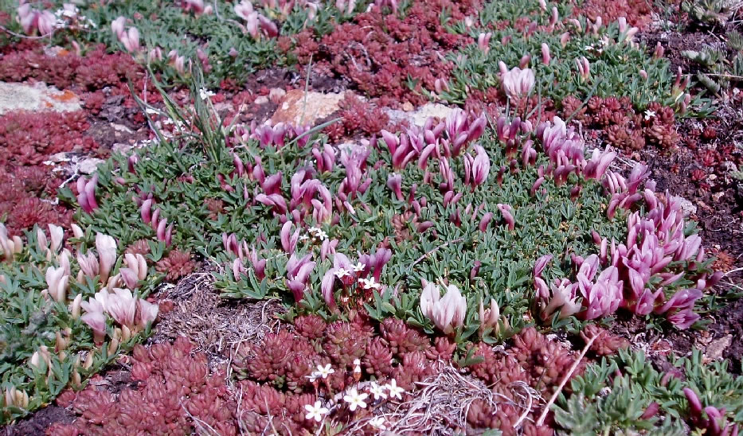

Producers

Plants

600 kc